**Software In Unnmaned Aerial Vehicles (Quadcopters)**

Faculty of Information Sciences and Computer Engineering

Marija Stojoska 211074

**Abstract**

Nowadays, drones are popular with their multipurpose functioning. They can be applied in different environments, especially those that are harmful and can cause health hazards to the human being. However, drones are expensive, have limitations in the lifting capabilities, difficult in control, and auto-balancing. The objective of this paper is to analyze free software for the design, analysis, modelling, and simulation of an unmanned aerial vehicle (UAV). Free software is the best choice when the reduction of production costs is necessary, nevertheless, the quality of free software may vary.

**Introduction**

Going back through history, unmanned aerial vehicles first invented by Reginald Denny during the First World War. At that time, the elements to built UAV were costly. The appearance of small-sized gyroscopes gave new propulsion to the development of the UAVs. All the necessary components and mechanisms in building different types of copters are cheap and available today. Nowadays, the application of the quadcopters is increasing widely, especially for dangerous tasks such as observation of the toxic lands, firefighting, rescue operations, and other activities that can be accomplished without physical intervention. This technology gives a chance to avoid severe damages to human life. On the other hand, most accidents take place under acute conditions, where unexpected difficulties may affect the work of the quadcopter. Therefore, the main aim of the research is to develop a robust quadcopter with advanced controllability based on the PID controller. UAVs have a large number of important advantages. First of all, errors arising from the human element are minimized. This is of great significance in terms of reducing crashes; moreover, UAVs can be produced in smaller sizes which contribute to their high performance maneuverability, wide range of use, ease of control and command.

The majority of missions are ideally suited to small UAVs which are either remotely piloted or autonomous. Requirements for a typical low-altitude small UAV include long flight duration at speeds between 20 and 100 km/h, cruise altitudes of 3–300 m, light weight, and all-weather capabilities. Although the definition of small UAVs is somewhat arbitrary, vehicles with wingspans less than approximately 6 m and masses less than 25 kg are usually considered in this category.

Because of the availability of very small sensors, video cameras, and control hardware, aerial systems as small as 15 cm with a mass of 80 g are possible to use for some limited missions. These systems are referred to as micro aerial vehicles (MAVs).

An extremely small (less than 15 cm), ultra-lightweight (less than 20 g) aerial vehicle systems, with the potential to perform indoor and outdoor missions, are known as nano aerial vehicles (NAVs).

Although the development and flight-testing of aircraft are well-documented engineering procedures, every UAV design, construction, implementation and test are unique and present different challenges to engineers, operators, and test teams. Because the performance of a UAV is dependent on both effective and highly responsive motor control as well as on aerodynamic efficiency, the high quality of the design and control of a UAV is increasingly required nowadays. Moreover, the criteria for UAVs may differ from those for manned aircraft; for example, the operation times of a UAV can be up to 10 times higher than a manned air vehicle, hence operation times of UAVs should be well considered. In addition, two important design parameters determine the power requirement of a UAV; range (based on the lift to drag ratio with fuel efficiency coefficient) and weight (based on total mass).

There are three basic phases in aircraft design: conceptual, preliminary, and detailed. Each design phase has characteristics which drive the tools and methods used as the design progresses. While it may be desirable to have the same suite of tools and methods spanning the design process, the widely varying characteristics of each of the phases makes this extremely difficult. For those organizations whose activities span all of these phases, there is a strong desire to have tools and methods which also span all of the phases, and this is most evident in the area of geometry definition.

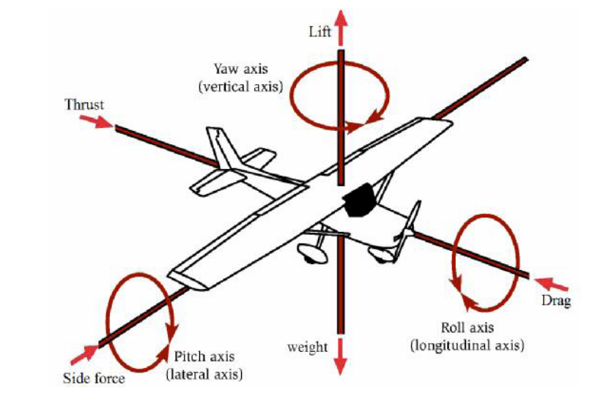

Picture 1: The forces and moments acting on an aircraft

**The Structure of a UAV System**

The study of structure, composition and function of the UAV system (UAS) is the premise. Any UAV system depends on its mission and range; however, most UAV systems include: airframe (physical and material structures) and propulsion systems, control systems, sensors for information collection, launch and recovery systems, communication links to get collected information from the UAV and send commands to it, and a ground control station. UAVs can also require additional sensors to avoid obstacles, i.e. power lines, birds, trees, buildings and other barriers. These types of avoidance sensors are called seeand-avoid or sense-and-avoid.

Although human personnel are part of the overall system, UAV systems include different levels of autonomy, ranging from remote control to fully automated mission completion including adaptation and decision making in response to changing operational conditions.

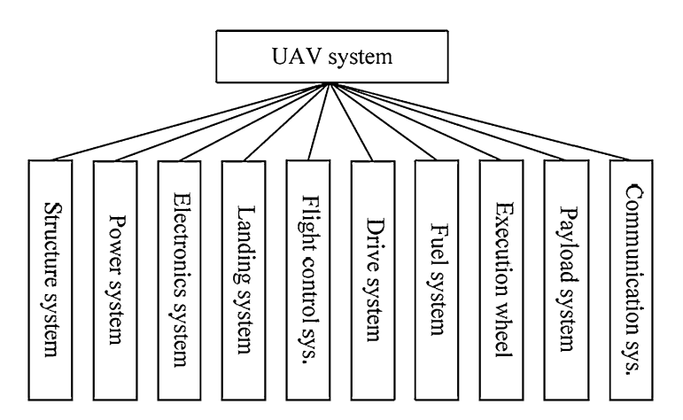

Picture 2: The composition of a UAV system

Sensors

Sensors can roughly be divided into two categories. The first one contains the sensors that are necessary for flight control, the second is sensors that are a part of the payload and provide mission-specific information.

A UAV system should theoretically be able to fly only with a 3-D accelerometer and a 3-D gyroscope. Ideally, if the initial position is known, all the later positions can be calculated only by integrating the resulting vector acceleration two times to find the position, while 3-D gyroscope signal is used to maintain flight stability. However, since all gyroscopes and accelerometers suffer from offsets and drifts, for instance with time and temperature, the accuracy of the calculated position will decrease over time.

The currently popular method of position fixing and navigation between points is by use of the Global Positioning System (GPS). GPS is available as two services, the Standard Positioning System (SPS) for civilian users and the Precise Positioning Service (PPS) for military users. Both signals are transmitted from all satellites. The accuracy of GPS position fixes varies with the receiver’s position and the satellite geometry. Height is also available from GPS, but to a lower accuracy.

The other class of sensors is the data-collecting sensors that provide useful information for the users. Examples are cameras, microphones, gas sensors, biological sensors, radiation sensors, and other sensors.

**Free Software**

Modelling and simulation software has been developed to assist in the design, development, test, and validation of complex aircraft systems. The fidelity and precision of the software ensure the reliability and efficiency of flying simulation system and can decrease the time and costs needed to development of any UAV.

Simulation program can run in two modes:

• real-time mode (used in real-time systems

• script mode (used in test process)

A large amount of freeware and open-source software for the modelling and simulation of aircraft exists on the Internet. Fortunately, much of the software can also be used for UAVs. As noted, this section probably does not include all of the free software, but tries to mention, describe, or analyze the most interesting applications.

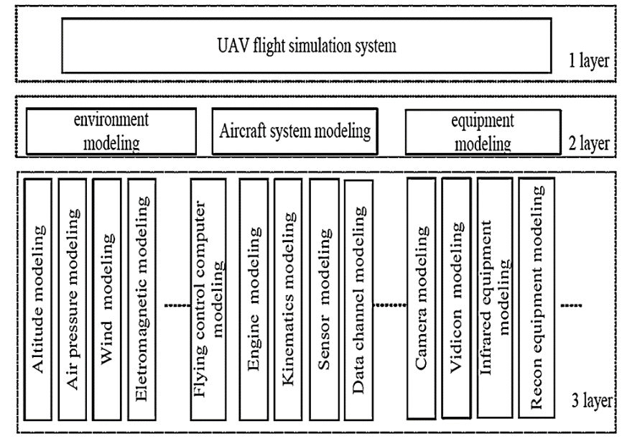

Picture 3: The structure of a UAV simulation system

**MIT and ESOTEC Software**

ESOTEC(Esoteric Technology) software, written by Carter, is an extension of MIT(Massachusetts Institute of Technology) software, which was developed mainly by Drela and Youngren.

In addition to described software, it is also worth mentioning the Transport Aircraft System OPTimization (TASOPT). TASOPT is a program for optimizing the airframe of a wing-tube transport aircraft, together with the engine parameters and operating parameters. However, despite there may be found some parts which can be useful, this software as a whole is probably inappropriate for UAVs.

**Public Domain Aeronautical Software (PDAS)**

Public Domain Aeronautical Software (PDAS) was founded to make this valuable software available to the aeronautical community for use on desktop computers. These programs include descriptions and complete public domain source code (written mostly in the FORTRAN programming language). The source code is not copyrighted and may be used in whole or part in any of aeronautical studies. Moreover, many programs have sample cases (both input and output). However, some of the programs are noted as ‘‘work-in-progress’’, indicating that they are lacking in instructions or documentation or do not run properly.

The list of the useful software for development of UAVs which is included in this subchapter may not be comprehensive. However, other interesting applications can be found in, for instance:

• Atmosphere (ATMOS)—characterizes the 1976 standard atmosphere to 1000 km altitude, including nonstandard atmosphere routines (hot, cold, polar,tropical) .

• Real Gas Properties (GASP)—computes real gas properties of ten important gases over a wide range of temperatures and pressures. Covers cryogenic regions and saturated liquid/gas regions.

• Thermodynamic and Transport Properties of Fluids (FLUID)—a companion program to GASP computes thermodynamic and transport properties of many gases. Treats air and steam as well as pure fluids.

• A Compressible Flow Calculator (VuCalc)—performs calculations in compressible fluid dynamics. There are six different classes of calculations: Isentropic Flow,Normal Shock, Oblique Shock, Standard Atmosphere,Rayleigh Flow, Fanno Flow.

**Conclusion**

This paper has described the most interesting free software for the design, analysis, modelling, and simulation of a UAV. Although the selection of the free software has been focused on small (mini) subsonic UAVs, the software can be used for other categories of aircraft in some cases; e.g. for MAVs, large gliders, transonic airplanes, etc. The fundamentals of airplane flight mechanics and aerodynamics, the general structure of a UAV, and the basics of the modelling and simulation of a UAV have also been presented.

The design, analysis, modelling and simulation are probably the first steps in development of a UAV. This approach is advantageous because a computer model allows better repeatability in testing. Consequently, it reduces the probability that the UAV and especially the autopilot will be designed and implemented incorrectly which could result in the UAV crash in the real world; and every crash can increase the distrust of UAVs and of their commercial using, especially in cities.

It has been explained that FDM and Flight Simulators are used in the development process of a UAV for the testing of its design and control systems. The combination of JSBSim Flight Dynamic Model and FlightGear Flight Simulator provide an excellent base for building the simulation environment. However, because the aerodynamic coefficients and other parameters are not generally provided by FDM, a large number of the programs for the UAV aerodynamic and mechanical analysis have been described in detail in this paper.

**References**

1. MPU-6050: TDK. (n.d.). Retrieved from https://www.invensense.com/products/motion-tracking/6-axis/mpu-6050/.

2. Kotarski, D., Piljek, P., & Matija, K. (2016). Mathematical modelling of multirotor UAV. *International Journal of*

*Theoretical and Applied Mechanics*, *1*, 233.

3. Luukkonen, T. (2011). Modelling and control of quadcopter. *Independent research project in applied mathematics,*

*Espoo*, *22*.

4. History of unmanned aerial vehicles. (2019, December 3). Retrieved from

<https://en.wikipedia.org/wiki/History_of_unmanned_aerial_vehicles>.